RESUME
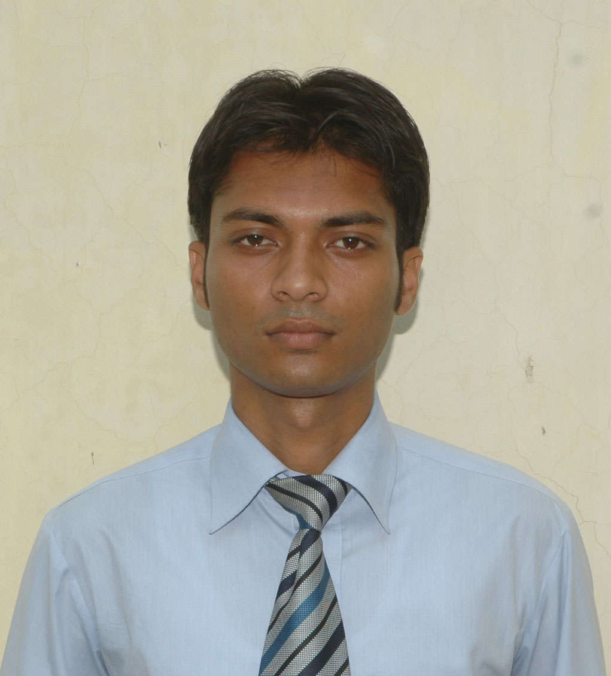
Vishwajeet Singh
RH.No. 20, Near Wagheshwar Mandir
Emerald Isle, Wagholi, Pune
Pin – 412207

Email - vishu0071@gmail.com
Contact no. – 9105691630, 8273540686

OBJECTIVES
Seeking a challenging position with opportunities for career advancement and learning to emerge as a Finance professional for organization and to prove myself as a reliable person of the organization by utilizing my knowledge, skills & attitude towards the growth of the organization.

PROFESSIONAL QUALIFICATION
MBA (2010-2012) from H.N.B. Garhwal University with Specialization in Finance as Major & HR as minor.

EDUCATIONAL QUALIFICATION
- Bachelor in Commerce with computer accounting, H.N.B. Garhwal University in 2010
- Higher Secondary, I.S.C. Board in 2007
- High School, C.B.S.E. Board in 2005

PERSONAL SKILLS
- A quick learner with ‘Can do’ attitude
- Good in grasping new thing
- Problem solving, influencing and relationship building skills
- Self motivated

EXTRA CURRICULAR
- Organized Quiz competition at MBA department, H.N.B. Garhwal University in the year 2011.
- Organized Get-Together function at Commerce department, H.N.B. Garhwal University in the year 2010
ACHIEVEMENT
- Certificate in Computer Applications
- Placement Coordinator at MBA Department , H.N.B. Garhwal University
- Attended 2 days “Entrepreneur Development Programme”
- Attended a workshop on “Research Methodology”.
- Attended a workshop on “Supply chain management in rural development”.

EXPERIENCE
- 15 months experience as an associate with an Insurance surveyor & Loss Assessor
Key Responsibilities: Responsible for carrying out survey of any loss occurred and preparing reports & assessment of loss.

- 07 months experience with Sbi Life Insurance as Operations Associate (from 23 Nov. 2016 to 26th June 2017)
Key Responsibilities: Scrutiny of proposal form received, cashiering of proposals & renewal instruments received, policy servicing, processing claims & surrender requests.

- Worked as Insurance claims executive at Lancers Risk Consultancy New Delhi
(16 August 2021 – 27th July 2022)
Key Responsibilities: Team Handling, claims investigation, preparing reports.

- Worked with DXC technology India pvt Ltd. From 28/07/2022 to 01/09/2023
(From 28 July 2022 to 01 September 2023)
Key Responsibilities: Underwriting New Business (Property and Casualty Insurance) in Llyods market (Processing Premium LPANS for OP Llyods London Market.)

- Last CTC: Rs. 3,00,000/- Lacs Per Annum

COMPUTER PROFICIENCY
Ms Office, Internet & E-Mail operations, Tally.

PERSONAL PARTICULARS
Date of Birth: 29/05/1989
Sex: Male
Martial Status: Unmarried
Nationality: Indian
Languages Known: Hindi and English
Hobbies: Traveling, making friends, playing snooker, music.

DECLARATION

I hereby declare that the above information provided by me is true to the best of my knowledge.

Current Location : Pune

Date: 02.12.2024
Place: Pune Vishwajeet Singh

