CURRICULAM VITAE
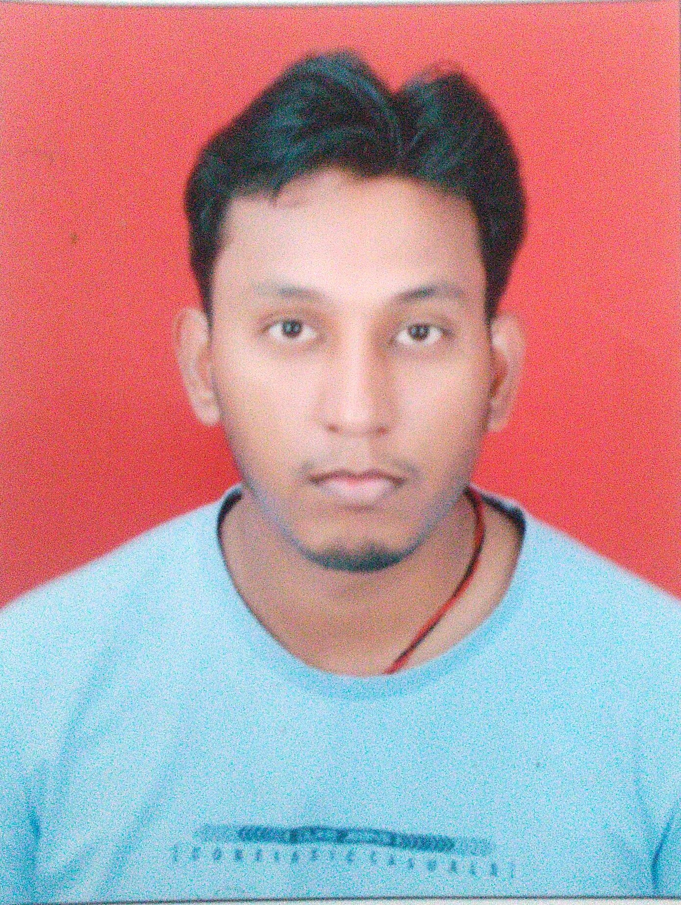

SUNNY NARAYAN
SUNNY NARAYAN, S/O VINOD KUMAR
YARPUR YOGIA TOLA, P.S.- GARDANIBAGH
POST.- G.P.O., DIST.- PATNA, PIN- 800001
STATE- BIHAR
E-mail - sunnynrn@gmail.com
MOBILE NO.- 07903142409

Passport no.- M5144041

CAREER OBJECTIVE:
To acquire a challenging, growth-oriented position that would best help me to utilize my skills and knowledge thereby contributing maximum towards the organization’s growth and value addition.

WORK EXPERIENCE

Employment:
1). Worked with JAMNA AUTO INDUSTRIES LTD, As an Asst. Manager (Paint shop Maintenance) from 21 FEB. 2019 to 14 Oct. 2019.

2). Worked with SURFIN COATING SYSTEMS PVT. LTD, as a sr. project engineer from 15 NOV. 2016 to 22 JAN 2019.

*). Working at Jamna Auto Industries Ltd, Yamunanagar (Haryana) for Top Coat Paint Shop Erection and Commissioning as a site in- charge.

*). Worked at Jamna Auto Industries Ltd, Jamshedpur for Top Coat Paint Shop erection & commissioning as a site in-charge.

*). Worked at Gabriel india ltd, Hosur (tamilnadu) for powder coating paint shop commissioning as a site in-charge.
*). worked at Thyssenkrupp elevators india pvt ltd, chaken (pune) for powder coating paint shop erection & commissioning as a site in-charge.

3). Worked with RDEVIS ENGINEERS PVT. LTD, new delhi as a Project engineer in from 25 Nov. 2015 to 8 NOV. 2016.

*) worked at SMR pvt ltd, noida sector-85, as a site in-charge.
*) worked at satyam auto pvt. Ltd, manesar, gurgaon for paint shop erection - commissioning and maintenance as a site in-charge.
*) worked at Shearling skins India pvt. Ltd, maneshar, gurgaon for top coat booth installation - commissioning and maintenance as a site in-charge.

4). Worked with Plustech systems & solutions India pvt. Ltd. as a Project engineer from 20 june 2014 to 20 Nov. 2015.

- Worked at TATA MOTORS, Jamshedpur for installation & commissioning of ED systems in CPS as a project engg.
- Worked at BAJAJ 3- WHEELER , Aurangabad shutdown work as a site in-charge.
- Worked at RENAULT-NISSAN Chennai, for manual bumper paint shop as a project engineer.
- Worked at METALMAN AUTO PVT. LTD, Aurangabad for PT CED paint shop maintenance as a project engg.
- Worked at BADVE ENGINEERING Ltd. Khalumbre (Pune), for PTED paint shop maintenance as a team leader.

5). Experience- 2 years of experience in John Deere India Pvt. Ltd. Sanaswadi, Pune
(Maharashtra) from 17 Sept. 2010 to 17 Sept. 2012 . Department – Engine.
Designation - Technical Trainee.

Company Profile:

Previous:
1). Plustech is in the business of industrial finishing with core competency in design, engineering, supply, installation and commissioning of surface finish systems. We are the right business partner for small & medium scale requirement of surface finishing Plants.

Previous:

2). John Deere The world famous tractors manufacturing company for domestic use & export up to 35HP to75HP.
- Company is an ISO 9000-2000 & 14001 certified Company.
- Company has got DPS Silver Organized by Deere & Company. MOLLIN (U.S.A)
- Company has 60% of export market over world reach.

INDUSTRIAL TRAINING
- 6 Days on job training in JOHN DEERE, Pune”

SKILL SET

Operating System | Windows 98/2000/XP,Basic Computer Aplication.
Software | Solid works (Basic), MS Office, MS Project, RAMCO (maintenance module).

JOB PROFILE AT PLUSTECH SYSTEMS & SOLUTIONS PVT. LTD (PUNE) AT PROJECT SITE

- To check the BOQ as per our drawing.
- Procurement of materials as per site condition and requirement.
- Workmen mobilization at site.
- Monitoring the daily activities at site.
- Ensure the customer satisfaction in our work quality.
- Analyze the work schedule and supervise our work till achieve.
- To be solve any problem at site itself.
- Timely follow up to the vendors and internal progress to meet the timeline and resolve the issues to meet the targets as per customer recommends.

JOB PROFILE AT PLUSTECH SYSTEMS & SOLUTIONS PVT. LTD (PUNE) AT MAINTENANCE SITE

- Daily Maintenance monitoring for meeting targets.
- Activities lean with Maintenance i.e. - 5S, CI, TPM, KAIZEN for any process related complaints.
- Maintenance activities (daily breakdown checklist approval & plan of preventive maintenance & maintain the toolkits on daily usable).
- NWG/CI concepts to recover any PTCED paint shop problems.
- Maintenance of TPM routine activities.
- Maintenance of material handling system.
- Maintenance of plc based (power & free) conveyor system.
- Breakdown Maintenance – Attending breakdowns, Manpower allocation as per skill requirement, Analysis of breakdown with corrective/ preventive actions.
- Preventive Maintenance - PM Planning, completion, timely updating PM check sheet.
- Planned Maintenance – Executing planned maintenance for Maintenance activities.
- Spare part planning for all machines.
- Skill improvement of maintenance operators.

SIGNIFICANT ACHIEVEMENTS IN JOB CAREER

- With help of cell members solved many problems as team leader through CIT (Continuous Improvement Team), NWG, Poka yoke.
- Awarded for Best NWG team for achieving the set goals.
- Have achieved award for best CI team.

STRENGTHS

- Positive thinking.
- Good inter personal relations & communication skills.
- Initiative & like to be a team member for achieving targeted goals.
- Adaptability towards new surrounding & enthusiastic of new aspect of works
- Quick learning capability.

ATTENDED TRAINING IN JDIPL

- 15 days Product training given by the John Deere, Pune.
- Total productive maintenance (TPM).
- Safety awareness training.
- Failure mode & effective analysis.
- 5s training.
- Poke yoke (Mistake proofing).
- Occupational health & safety assessment series.
- Material safety data sheet (MSDS).
- Process knowledge (OMS, SOE, CONTROL PLAN).

EDUCATIONAL QUALIFICATION

QUALIFICATIONS | YEAR OF PASSING | PERCENTAGE %
B-Tech in mechanical engineering | 2014  (Distance education) | 65 %
Diploma in mechanical engineering | 2010 | - %
Hsc (10+2) | 2007 | 50 %
Secondary School (10th) | 2004 | 56 %

PERSONAL DETAILS

Name : Sunny Narayan

Father’s Name : Late Vinod Kumar

Date of Birth : 18-08-1989

Sex : Male

Blood Group : “B” positive

Nationality : Indian

Marital Status : Single

Languages Known : Hindi, English.

DECLARATION

I hereby declare that the above mentioned information is correct up to my knowledge and I bear the responsibility for correctness of above mentioned particulars.

Date: Yours Truly

Place: (Sunny Narayan)

